**Vendor Registration Form**

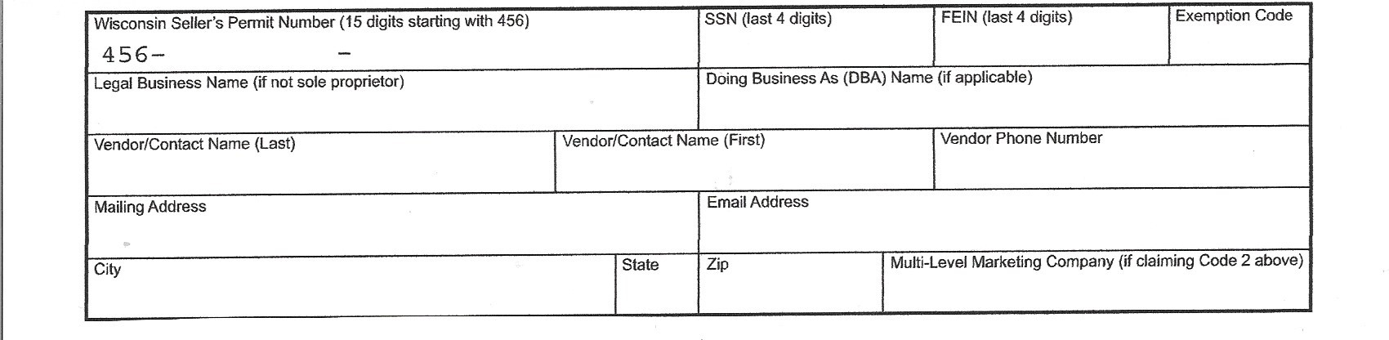

_____________________________________________________________________________________________________

Signature of Vendor Date